SUBSCRIBERS GALORE: EXPLORING WORLD’S TOP YOUTUBE CHANNELS

1.INTRODUCTION

1.1 OVERVIEW:

The **Overview** tab in YouTube Analytics gives you a high-level summary of how your channel and videos are performing on YouTube. The key metrics card shows your views, watch time, subscribers, and estimated revenue (If you’re in the [YouTube Partner Program](https://support.google.com/youtube/answer/72851)). **Note**: Some reports may not be available on mobile devices.

1.2 PURPOSE:

A YouTube channel can help your business reach and connect to a larger audience. Here are the steps you need to follow to create a YouTube channel. YouTube is one of the most-visited websites on the internet, with users from all over watching videos to laugh, get educated, or see clips from their favorite TV shows.

## 2.PROBLEM DEFINITION & DESIGN THINKING

## 2.1 EMPATHY MAP:

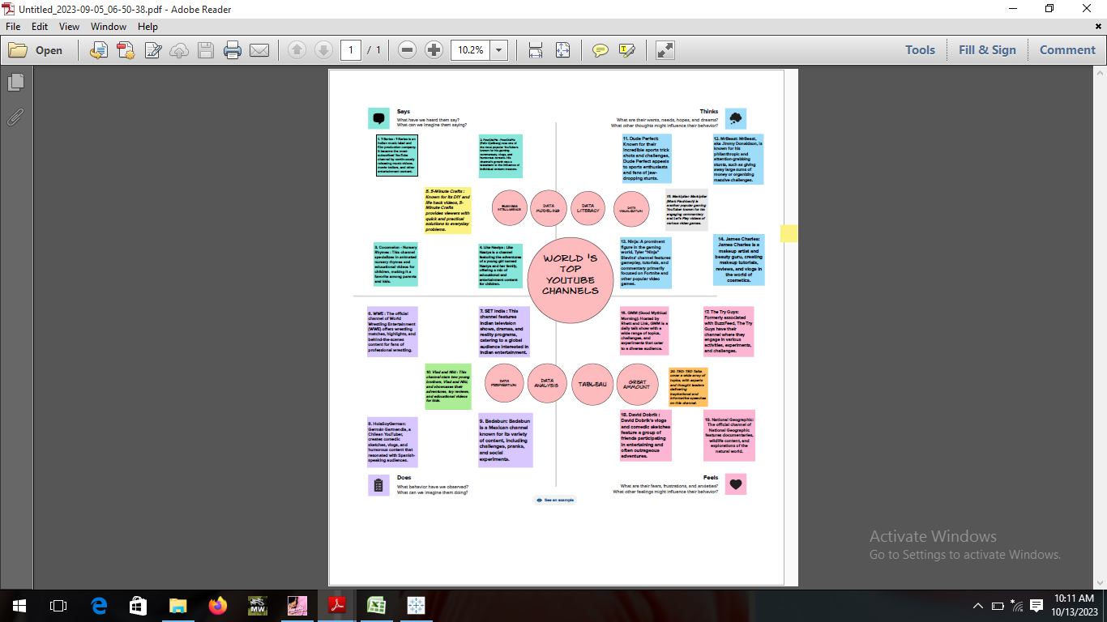

# 2.2 IDEATION & BRAINSTORMING MAP:

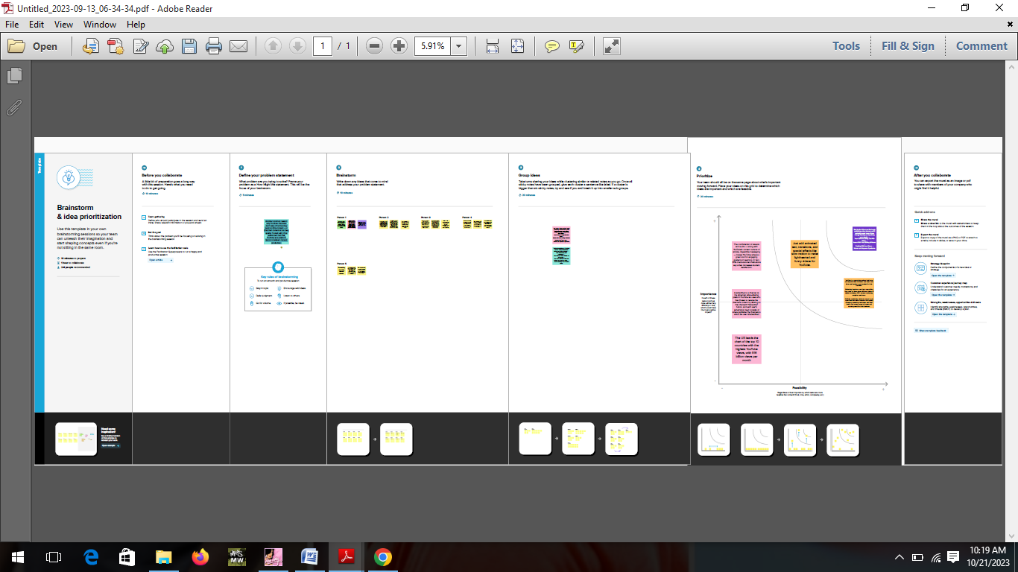

# 3.RESULT:

# Screenshot (21).png 4.ADVANTAGES AND DISADVANTAGES:

# ADVANTAGES:

* Exposure to a Worldwide Audience. ...
* Marketing on YouTube Will Help You Get Found on Google. ...
* Gain Qualified Traffic. ...
* YouTube Ads Can Help You Reach Even More People. ...
* Other Ways To Repurpose Your Videos.

# DISADVANTAGES:

* Ads- a drawback of YouTube for the audience. ADVERTISEMENT. ...
* A lot of distraction. ADVERTISEMENT. ...
* Obscenity- one of the biggest drawbacks that YouTube has. The kind of content that is uploaded on YouTube is largely in control today. ...
* Defamation and Bullying. ...
* Making money isn't that easy.

# 5.APPLICATION:

**#1** YouTube is the second-largest search engine in the world, so creating a YouTube channel is a fantastic way to enhance your content’s visibility.

**#2** YouTube can offer you a more intimate and engaging connection with your audience. You can respond to viewers’ comments and communicate with them, thereby fostering the development of a community around your channel.

**#3** [Your YouTube channel can be monetized](https://www.tubebuddy.com/blog/how-to-make-money-on-youtube/) through Google AdSense, sponsorships, and many other ways. Being a successful content creator allows you to generate revenue with your work.

**#4** YouTube enables you to demonstrate your expertise and share your knowledge. Whether you are a musician, an artist, or a scientist, you can use YouTube to inspire people with your talents.

**#5** YouTube is an excellent platform for documenting one’s life and experiences. It can be used to create a visual journal of your travels, interests, and daily activities.

**#6** It’s also an excellent medium for reaching a global audience. No matter where in the world you are, you may share your material with individuals from every country..

**#7** YouTube encourages collaboration with other content creators and the cross-promotion of content. This can help you reach a larger audience and establish connections with other creators.

**#8** YouTube is always changing, which means that creators are always getting new tools and features to help them grow their channels.

**#9** YouTube is a great place to connect with people who like the same things you do and build a supportive community. You can find and join groups and forums that are related to your interests and talk to other people who make content or watch it.

**#10** Creating a YouTube channel is a fantastic way to show the world what you can do and how creative you can be. It’s a fun and rewarding hobby that can make your life and the lives of other people just that little bit better.

# 6.CONCLUSION

# After reviewing the results from the survey, I was not really surprised with the responses that I received. Majority of the people that I surveyed are on YouTube all the time and its to watch homemade  or uploaded videos.  I was shocked to learn that only one person has heard of YouTube EDU. I have heard of YouTube EDU, but I have never used it. This shows that many Universities don't use YouTube EDU in their classrooms. I learned that many people believe that YouTube should be used more in classrooms. This could be because YouTube has more to offer than just uploaded videos by users. YouTube has contracts with certain networks and many educational videos are being put on YouTube everyday. I was not expecting to learn that majority of the people are on YouTube less than an hour a week. I believe this is due to students being full time students and parents working full time jobs and taking care of their kids which gives no  time  for them to watch YouTube videos.       If I were to follow up on this research, I would definitely like to get survey responses from younger students, such as middle schoolers and high schoolers. This would give me more of a understanding on what younger students think about YouTube in the educational sense. Also, I would like to survey just teachers and find out their thoughts on YouTube and if their responses are similar or different than the college students responses.        YouTube has an important part in education, because it allows students to learn more about a particular topic or subject just by watching a short video. YouTube is full of different types of videos that can easily be incorporated and used in classrooms that will give students a better insight on a particular subject. Many online classes today are using YouTube as a source for students to learn. One course that uses YouTube a lot is History. History courses have documentary clips and videos that can be found on YouTube. Having YouTube be a part of education can help students get the one- on -one time with their teachers and ask questions that they may have. Students can watch and take notes from the lecture on YouTube and work on their homework at home, then come to class the next day and ask their teacher any particular questions that they may have regarding the assignment or the lecture.      In the future I predict that  schools will no longer be banning YouTube from their computers and YouTube will be used for watching any educational videos at home.